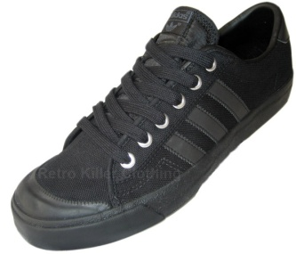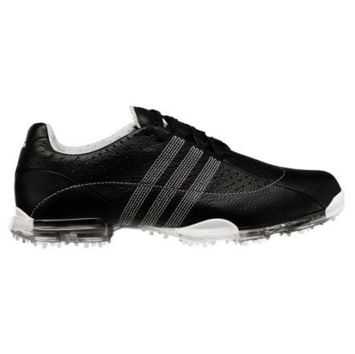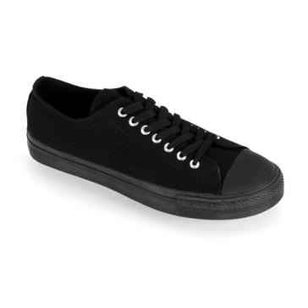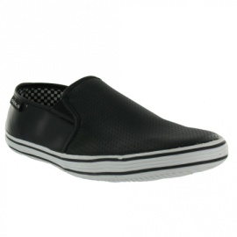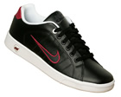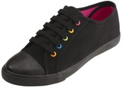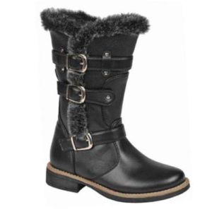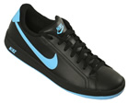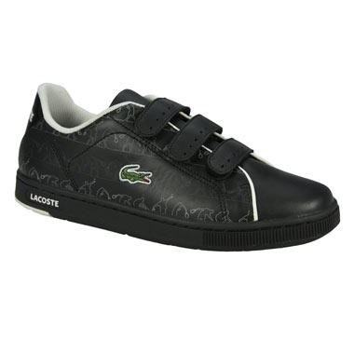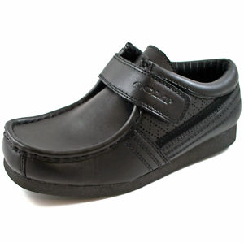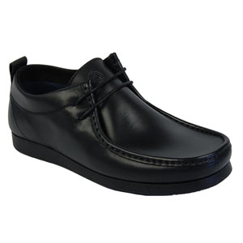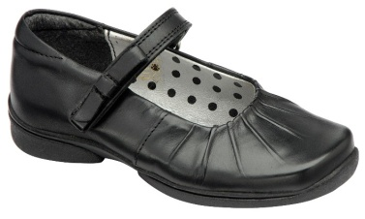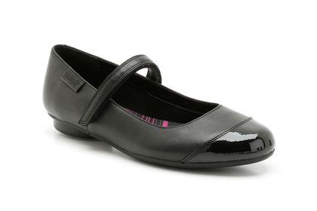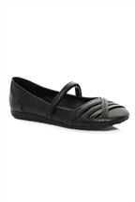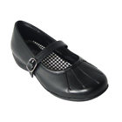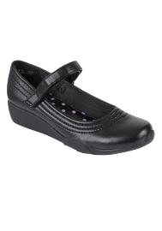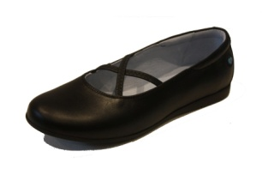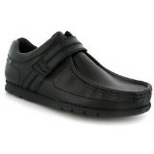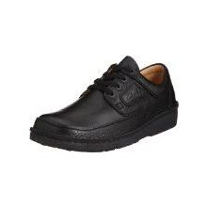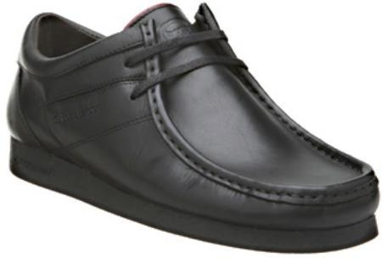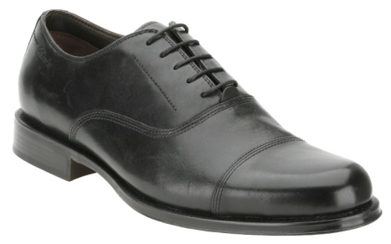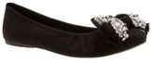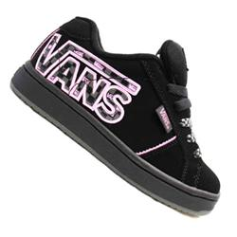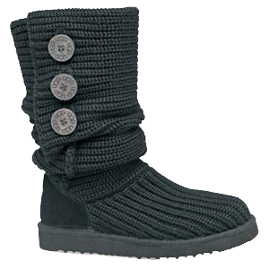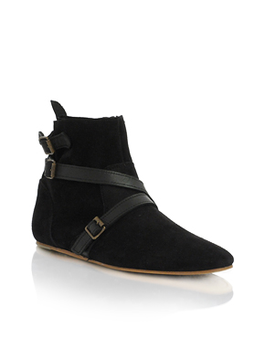

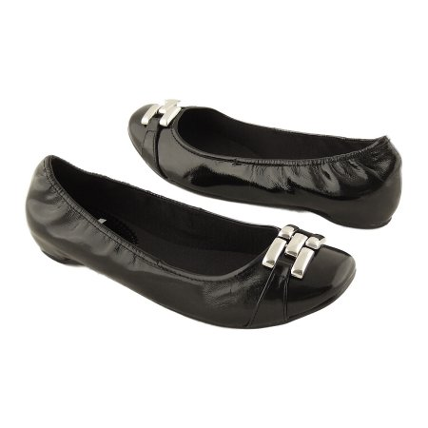

**CORRECT FOOTWEAR MUST BE WORN**

**IF YOU ARRIVE IN SCHOOL WEARING INAPPROPRIATE FOOTWEAR, YOU WILL BE ISSUED WITH A ‘TEMPORARY’ PAIR OF APPROPRIATE SHOES. ANY PUPILS WHO FAIL TO COMPLY WITH THIS RULING WILL BE SENT HOME.**

**ACCEPTABLE FORMS OF FOOTWEAR**

**ST ANTONY’S CATHOLIC COLLEGE**

**A QUICK REMINDER. SCHOOL SHOES SHOULD:**

* **BE PLAIN BLACK**
* **BE LEATHER OR ANOTHER TYPE OF DURABLE MATERIAL- NOT CANVAS**
* **HAVE NO EXTRA COLOURS**
* **HAVE NO EMBELLISHMENTS**
* **HAVE NO DESIGNER NAMES OR LOGOS VISIBLE**
* **NOT BE ABOVE THE ANKLE. BOOTS ARE NOT ALLOWED (THE HEADTEACHER WILL REVIEW THIS DURING THE WINTER TERM)**

**UNACCEPTABLE FORMS OF FOOTWEAR**