**TAKE A LOOK AT YOURSELF? ARE YOU IN CORRECT UNIFORM?**

**WHAT SHOULD I BE WEARING?**

* **BLAZER**
* **SHIRT OR BLOUSE**
* **TIE**
* **TROUSERS OR SKIRT**
* **JUMPER**
* **SHOES**

**WHAT AM I NOT ALLOWED TO WEAR?**

* **HOODIES**
* **SCARVES**
* **GLOVES**
* **HATS**
* **JEWELLERY**
* **CARDIGANS**
* **TRAINERS/ PUMPS/ UGG BOOTS ETC**
* **LEGGINGS/ JEANS/ JEGGINGS**

**WHAT ARE THE RULES?**

* **NON UNIFORM ITEMS CAN NOT BE WORN INSIDE THE SCHOOL BUILDING.**
* **ALL NON UNIFORM ITEMS WILL BE CONFISCATED AND YOU CAN**

**ONLY COLLECT THEM AT THE END OF THE DAY.**

* **IF YOU ARRIVE IN SCHOOL WEARING INAPPROPRIATE FOOTWEAR,**

**YOU WILL BE ISSUED WITH A ‘TEMPORARY’ PAIR OF APPROPRIATE SHOES.**

**WHAT SHOULD I DO IF I AM CONFUSED ABOUT THE RULES?**

* **SPEAK TO YOUR FORM TUTOR WHO WILL EXPLAIN IN FURTHER DETAIL**

[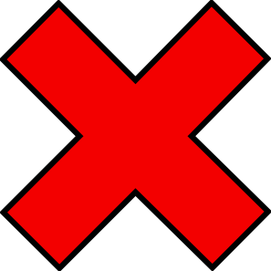](javascript:edit(28862))

[](javascript:edit(159481))

**ST ANTONY’S CATHOLIC COLLEGE**