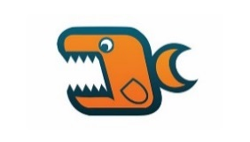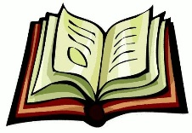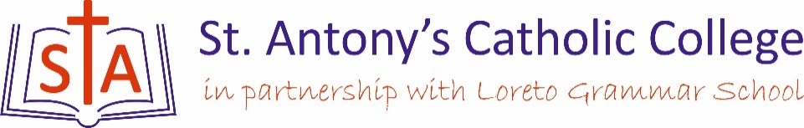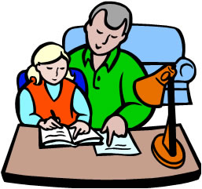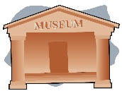What is your child learning in Art?

Outside of the classroom

Visits to the sea-life centre

Art Gallery visits such as Manchester Art Museum

Read news articles about sea pollution.

Family Friendly Homework

Try sketching ‘natural forms’. This could be anything that is not man made, e.g. animals, plants.

Resources to Challenge

Try using YouTube to help model paper mechanisms.

Research Origami – Practice making a range of models!

Key Dates & Deadlines

This topic spans half of Year 7 with a variety of investigation, design and make tasks. Mini projects will run throughout the year with deadlines to set by class teachers.

Topic of Study

Washed ashore – the study of natural forms with a particular focus on sea-life and the global impact of waste.

Resources to Support

Washed ashore website: www.washedashore.org

Discussion starters

How can we reduce how much waste we create?

Where does the rubbish or recycling we dispose of end-up?

Can individuals REALLY make a difference?