Friday 10th February 2017

Dear Parents/Carers,

I write to ask for your support as your son/daughter breaks up for half term. We’ve had a wonderful time with Year 11 this week as they’ve worked through the European Computer Driving Licence with many of them achieving the equivalent of an A* or A at GCSE. We also received fabulous feedback from the students who participated in an inspirational seminar focused on exam success called ‘Ace your exams!’. Additionally, all of the students shared in a retreat with Father David at English Martyrs Church looking towards their futures. Overall a really aspirational week.

My reason for writing is not only to update you on the above, but to also say that now is the time for your son/daughter, if they haven’t done already, to begin to prepare for their GCSEs in earnest. Over half term they should be revising for at least one or two hours a day and this level of revision needs to continue after they return on Tuesday 21st February 2017. Paraphrasing the famous quote by Benjamin Franklin, if they fail to prepare, they must prepare to fail. Please help encourage them at home as we will continue to do at school.

Thank you to all those who attended Parents Evening last night. Supporting your child in this way makes a significant impact on their educational outcomes.

Yours faithfully,
Fiona Wright
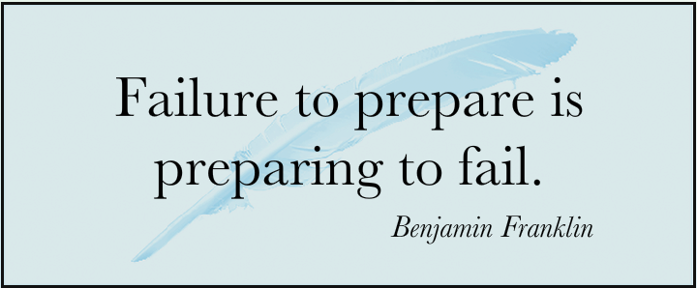
Associate Headteacher

