April 2024

Dear Applicant,

Thank you for your interest in the permanent full time post of Curriculum Lead of Design & Technology at St Antony’s Roman Catholic School. I have provided further details below which I hope will provide you with ample information about the post. Please see our website for details of the school and visit our Facebook, Twitter and Instagram pages for the most up-to-date news and information. We are seeking to appoint an outstanding colleague who can teach at both Key Stage 3 and 4 in this very effective department. The starting date is 1st September 2024.

The Department
The Design & Technology Department encompasses Graphics, Food, 3D Design and Textiles, along with sharing space with Art. The department has a well-equipped suite of practical rooms and use of ICT facilities including interactive screens.

- 3D Design has a well-equipped workshop which includes CAD/CAM facilities, laser cutter, 3D printer and electronics equipment. The workshop is a spacious room and recently been refurbished.
- Graphics has a suite of computers installed with a range of industry standard software. This room has recently been refurbished and is equipped for sublimation printing and heat transfer printing.
- Textiles has a well-equipped workshop with a practical area, 20 sewing machine stations and a design area with computer access.
- Food has a well-equipped practical room with plenty of storage space.

In KS3 pupils are taught on a carousel in Design & Technology, studying four materials areas in each year. At KS4 pupils currently have the option to take Eduqas Hospitality & Catering or choose from a selection of subject areas under the Eduqas GCSE Art, Craft & Design specification title. Results in Art, Craft & Design are strong and options in Design & Technology are popular. A full-time technician supports the department with the day to day organisation and running of lessons.

Application process
I hope that the information that has been provided here, and on our website has hooked your interest and I look forward to hearing from you. Should you wish to meet with me prior to applying I should be delighted to do so. Please contact school via email on head@st-antonys.com to arrange a mutually convenient time.

Should you decide to apply for the post all of the relevant documents are on our website (www.st-antonys.com). Please refer firstly to the ‘Guidance Notes for Teaching Staff Applicants’. Complete the application form, together with a letter of application outlining your vision and philosophy for the teaching of Design & Technology at St Antony’s Roman Catholic School, your relevant experience and your understanding of current, relevant educational developments. Your letter should not exceed 2 pages of A4 in length. Please note that we do not accept Curriculum Vitae.

The closing date is Friday 26th April at 12pm. If you have not heard from us within 2 weeks of the closing date, please assume that your application has been unsuccessful on this occasion. We are unable to provide feedback on unsuccessful applications.

I look forward to receiving and reading your application.
Yours faithfully,
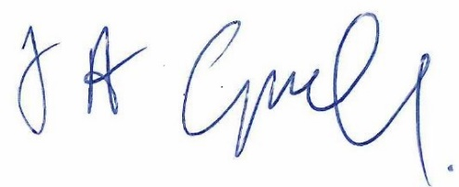

Anthony Campbell - Headteacher

