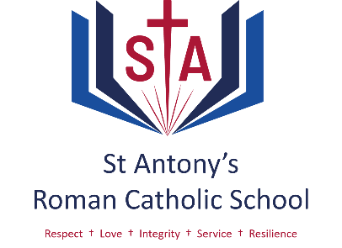

An evaluation of the CEIAG provision at St Antony’s – September 2024

As shown in the table below, St Antony’s students have a lower percentage of NEET (Not in Education, Employment or Training) students’ trend than the national average since the COVID pandemic. This suggests that our students usually move on to appropriate next steps as supported by the St Antony’s CEIAG programme. We recognise the data from 2023 is disappointing but also note that this cohort numbered only 104 and so this data reflects 5 individuals.

|  |  |  |  |  |  |  |
| --- | --- | --- | --- | --- | --- | --- |
| %NEET | Latest average | 2023 | 3 year trend | 2022 | 2021 | 2020 |
| St Antony’s | 1.64 | 4.81 | 0.58 | 1.74 | 0.00 | 0.00 |
| National | 1.84 | 1.36 | 2.00 | 2.20 | 1.9 | 1.90 |

**% NEET** **2020** **2019** **2018** **2017** **2016**

St Antony’s works with the Compass Plus Careers and Enterprise evaluation service. They review the careers education offered by the school and assess this against the 8 Gatsby Benchmarks. Their evaluation of our provision is below.

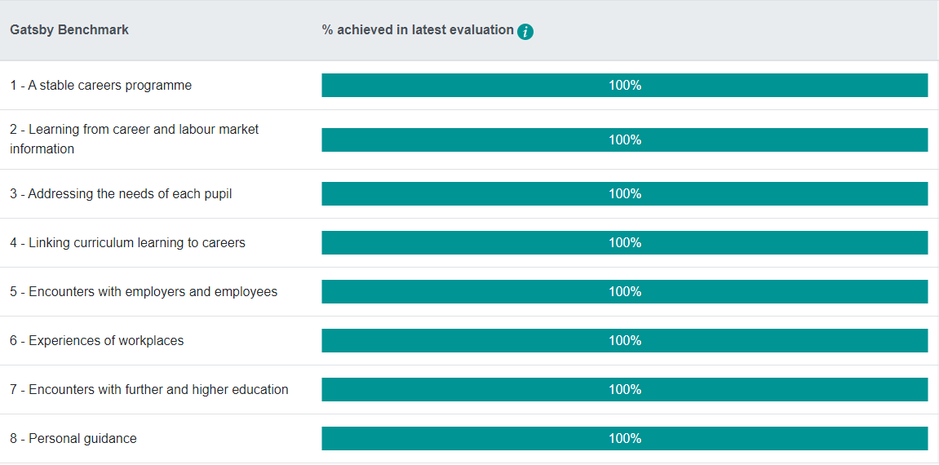

Next review – Spring Term 2025