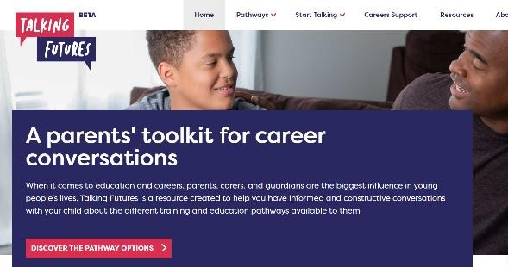

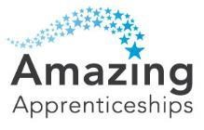

Using Talking Futures

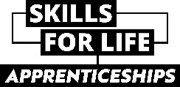Talking Futures has a range of resources to help parents to further research and develop careers conversations.

This website can be useful to support careers conversations with students or for further information about all pathways. <https://www.talkingfutures.org.uk/>

For further information to support you to feel confident having careers [conversations, please refer to https://st-antonys.com/curriculum/careerseducation-information-advice-guidance](https://st-antonys.com/curriculum/careers-education-information-advice-guidance)